INTRODUCTION

* + Overview

Salesforce can help dealerships and service centers monitor vehicle performance and maintenance needs.This can help service centers proactively identify and resolve vehicle issues before they become major problems

* + Purpose

The purpose of Vehicle Management is to ensure the effective and efficient use of vehicles to meet of an organization or individual .This includes activities such ascquaring,maintaining,tracking,and disposing of vehicles in cost-effective and sustainable manner

Problem Definition & Design

Thinking

2.1 Empathy Map

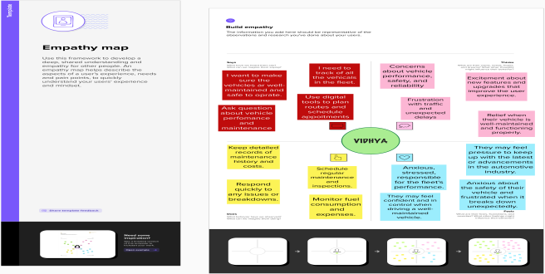

2.2 Ideation & Brainstorming Map

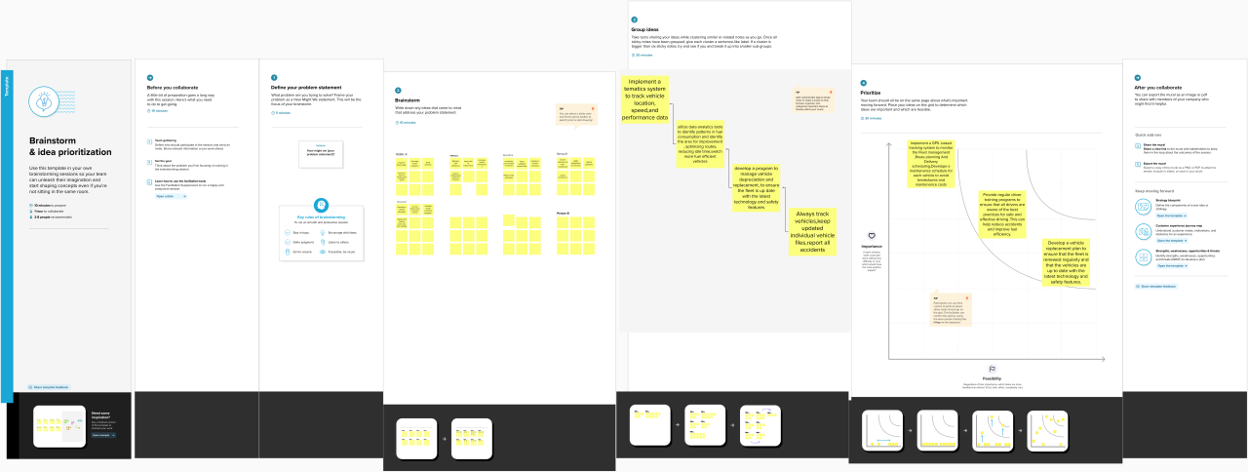

RESULT

3.1 Data Model

|  |  |  |  |
| --- | --- | --- | --- |
| OBJECT | | FIELD NAME | DATA TYPE |
| VEHICLES | | CUSTOMER NAME | TEXT |
| CUSTOMER MOBILE NO | NUMBER |
| VEHICLE TYPE   * 2 WHEELER * 4 WHEELER | PICKLIST |
| 2 WHEELERS   * HERO * HONDA * BAJAJ * ROYAL ENFIELD * TVS * KINETIC * OLA * JAWA * SD * BATTERY | PICKLIST |
| 4 WHEELERS   * RENAULT * SKODA * HONDA * HYUNDAI * SUZUKI * MAHINDRA * VOLKSWAGEN * BENZ * AUDI * VOLVO | PICKLIST |
| VEHICLE NAME | TEXT |
| VEHICLE NO | TEXT |
| COLOUR | TEXT |
| DRIVER | DRIVER NAME | | TEXT |
| LICENCE NO | | TEXT |
| MOBILE NO | | NUMBER |
| FAIR PER HOUR | | TEXT |
| VEHICLE | | LOOKUP(VEHICLE) |

3.2 Activity & Screenshot

1.CREATION OF A VEHICLES OBJECT:

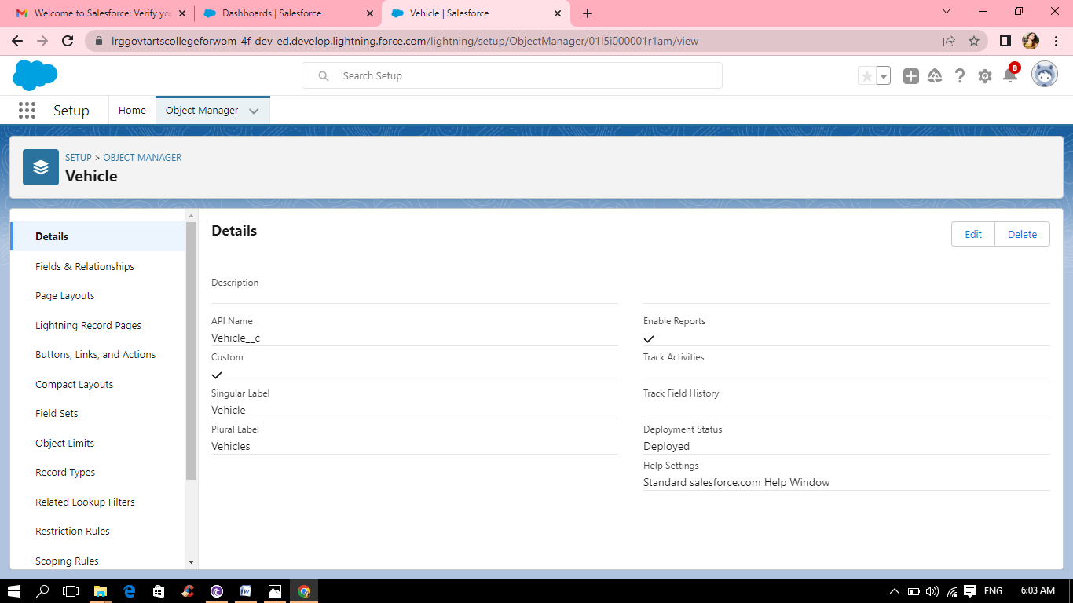

2.CREATION OF DRIVER OBJECT:

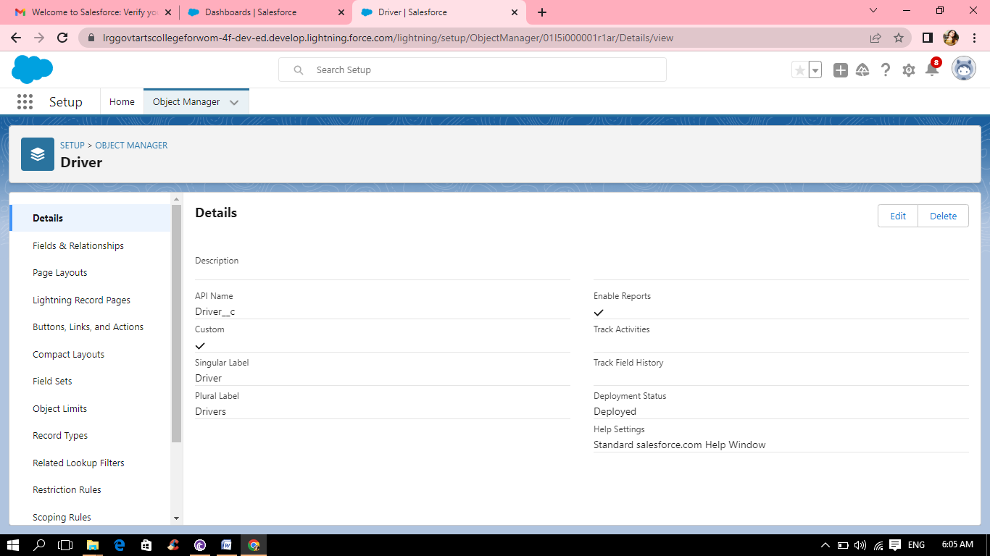

3.CREATION OF FIELDS IN VEHICLES OBJECT:

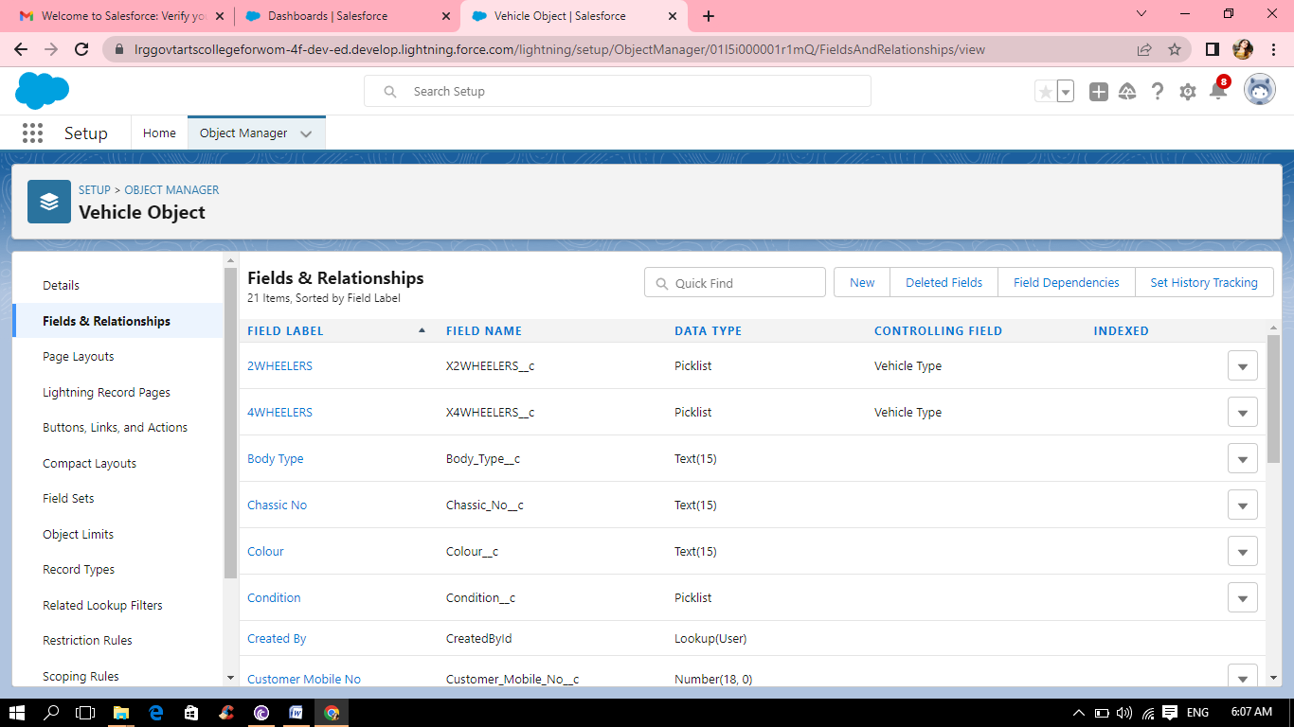

4.CREATION FIELDS IN DRIVER OBJECT:

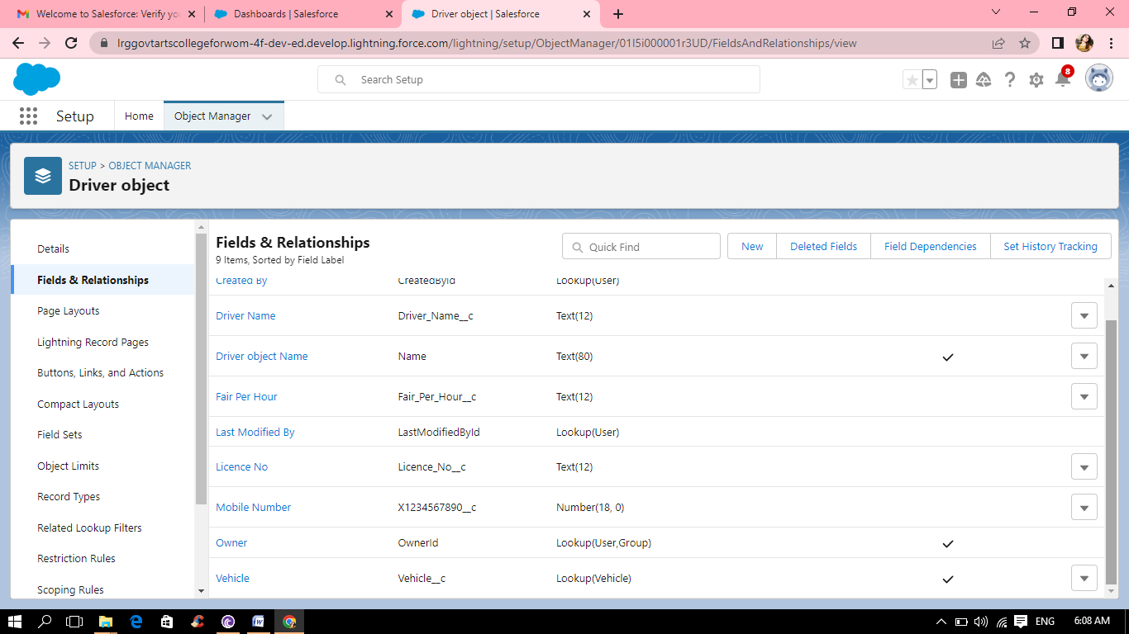

5.CREATION FIELD DEPENDENCIES:

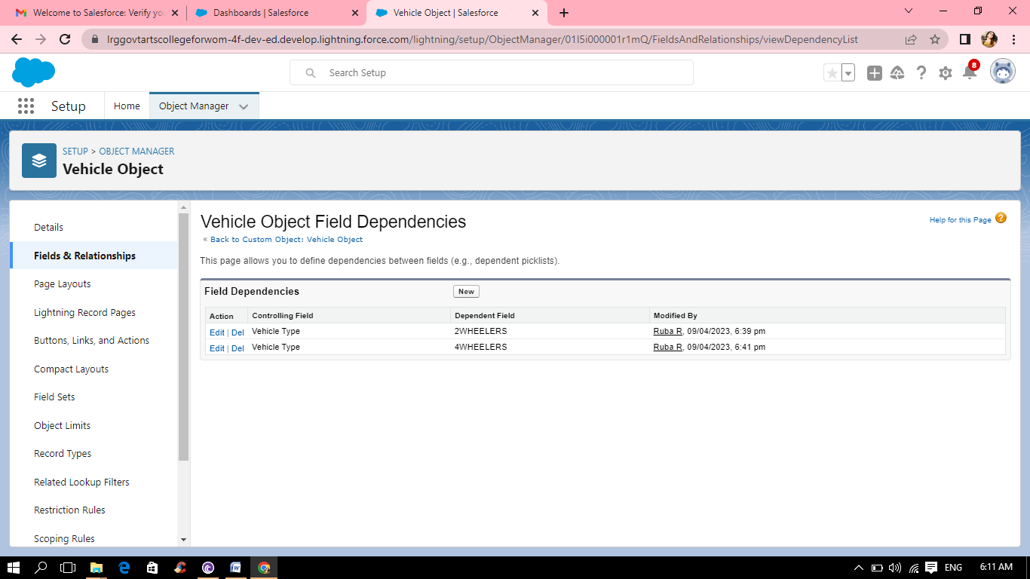

6.CREATION OF LIGHTNING APP:

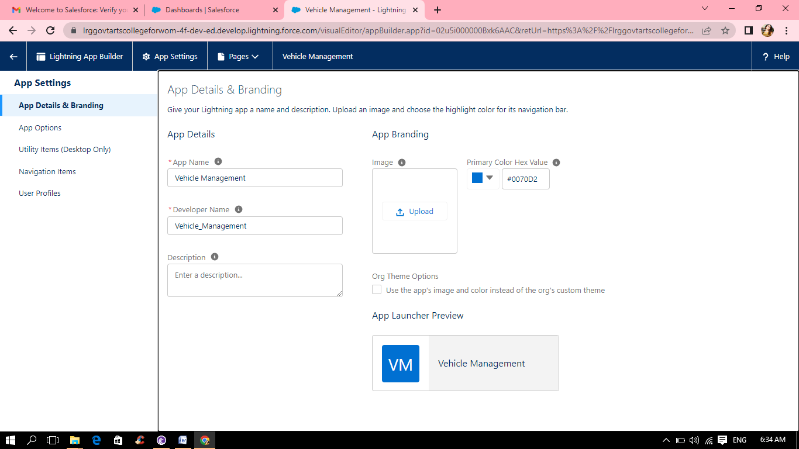

7.CREATION OF PROFILES:

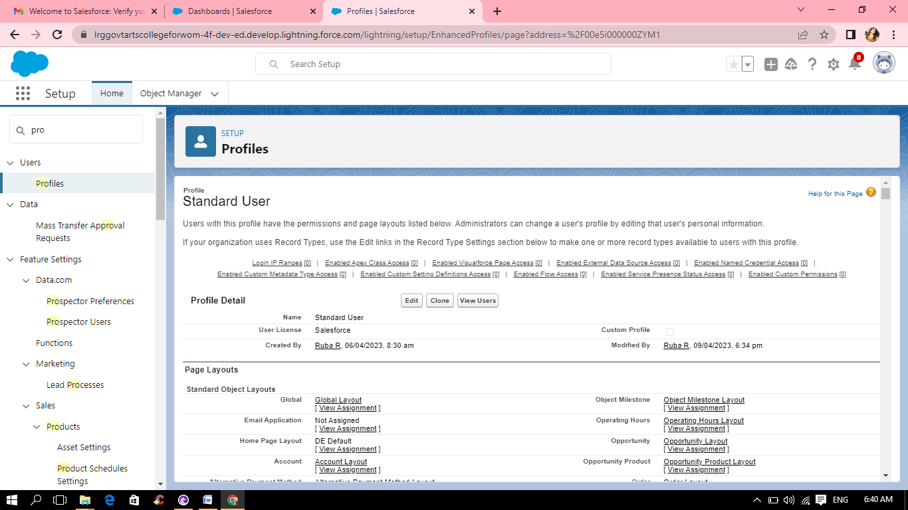

8.CREATION OF USERS:

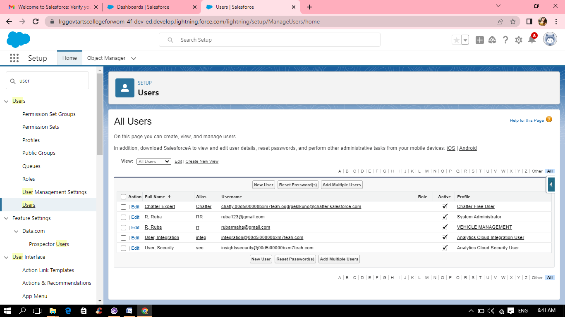

9.CREATION OF REPORTS:

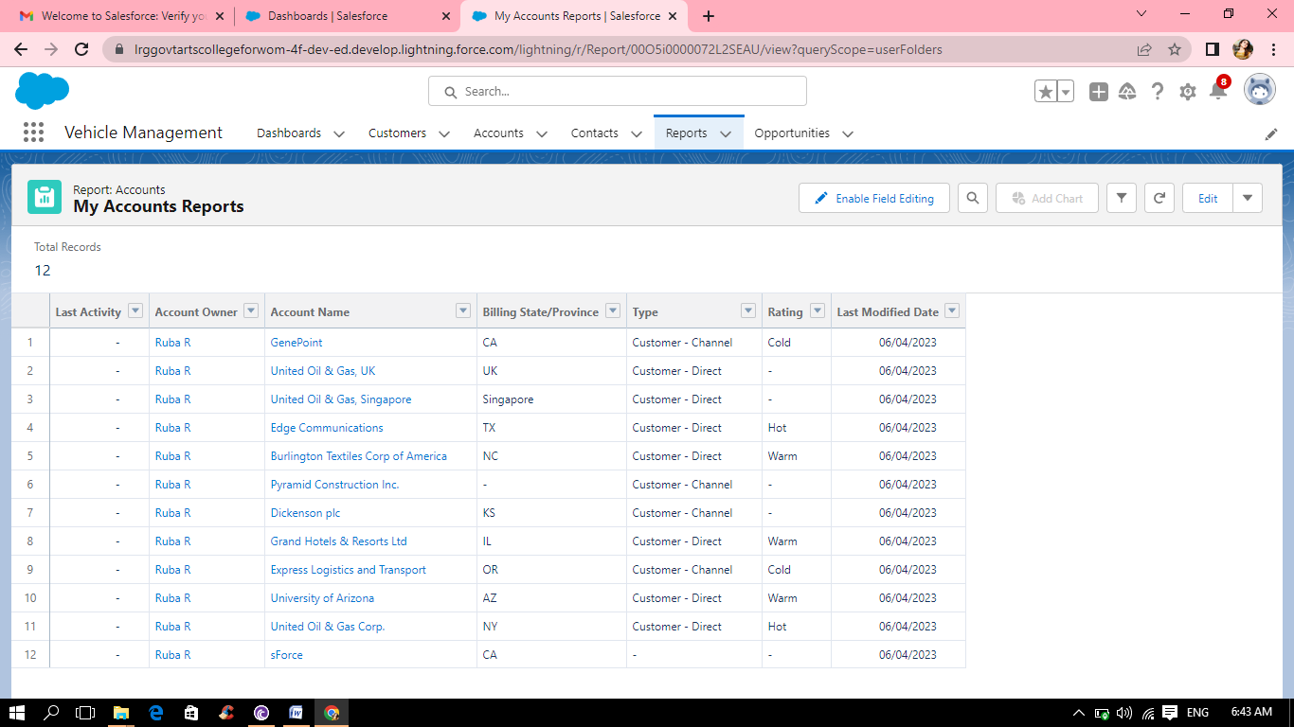

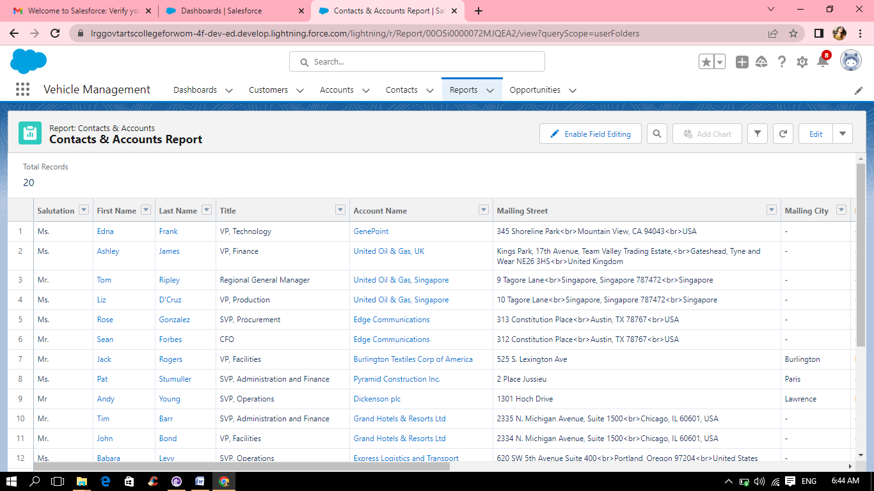

10.CREATION OF DASHBOARDS:

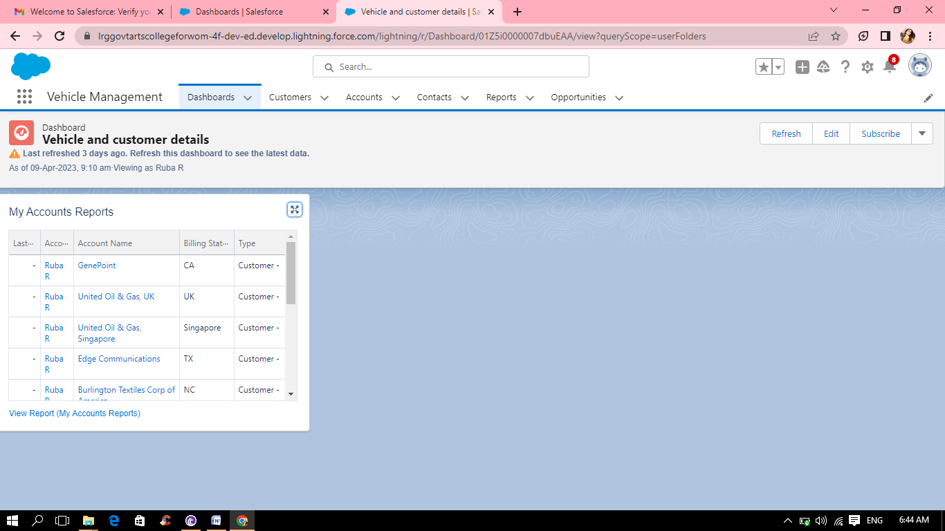

Trailhead Profile Public URL

Team Lead – https://trailblazer.me/id/rmaha365

Team Member 1 –https://trailblazer.me/id/ramyr29

Team Member 2 –https://trailblazer.me/id/rraveena

Team Member 3 –https://trailblazer.me/id/sruts26

Team Member 4 –https://trailblazer.me/id/vidhs15

ADVANTAGES & DISADVANDAGE

ADVANTAGES:Salesforce offers a high level customization ,enabling companies to tailor their vehicle management system to fit their specific business needs.Salesforce offers collaboration tools,enabling different departments and stakeholders to work together and share information in real-time.It wii be perfectly secured .Because salesforce is a cloud –based system,there may be concerns about data security and privacy.

DISADVANTAGE:Salesforece can be expensive,particularly for small business .The cost of customization ,integration, and ongoing support can add up quickly.Training is necessary for employees to use salesforce effectively ,which can be time consuming and costly.

APPLICATIONS

Salesforce can be used to manage customer relationship and track sales activities related to vehicles.Salesforce can be used to manage vehicle service and maintenance schedules,track service requests,and monitor service history.Salesforce can be used to analyze vehicle sales and service data,generate reports,provide insights to inform business decisions.Overall ,using Salesforce for vehicle management can help streamline processes,improve customer relationships,and drive business growth.

CONCLUSION

Salesforce can be a powerful tool for vehicle management .Salesforce can be used to track the location and status of vehicles in real-time.Overall,using salesforce for vehicle management can help businesses improve the efficience of

Their fleet ,reduce costs,and ensure that there vehicles are well-maintained and in good working condition .

FUTURE SCOPE

In the modern age ,many people have a vehicles.Now,vehicle is a basic need every places under the process of urbanization.There are many corporate officers and shopping centers etc.Every systems might be computerized or non-computerized.With the help of computerized system can deliver good service to customers.